***Jenkins Installation on CentOs 7 /Red Hat***

Website : <https://www.jenkins.io/>

Step 1 :

## Red Hat / CentOS

You can install Jenkins through yum on Red Hat Enterprise Linux, CentOS, and other Red Hat based distributions. You need to choose either the Jenkins Long Term Support release or the Jenkins weekly release.

### Long Term Support release

A [LTS (Long-Term Support) release](https://www.jenkins.io/download/lts/) is chosen every 12 weeks from the stream of regular releases as the stable release for that time period. It can be installed from the [redhat-stable](https://pkg.jenkins.io/redhat-stable/) yum repository.

sudo wget -O /etc/yum.repos.d/jenkins.repo \

https://pkg.jenkins.io/redhat-stable/jenkins.repo

sudo rpm --import https://pkg.jenkins.io/redhat-stable/jenkins.io.key

sudo yum upgrade

sudo yum install epel-release java-11-openjdk-devel

sudo yum install jenkins

sudo systemctl daemon-reload

Step 2

### Start Jenkins

You can start the Jenkins service with the command:

sudo systemctl start jenkins

You can check the status of the Jenkins service using the command:

sudo systemctl status jenkins

If everything has been set up correctly, you should see an output like this:

On Boot Enable

systemctl enable jenkins

Optional :

If you have a firewall installed, you must add Jenkins as an exception. You must change YOURPORT in the script below to the port you want to use. Port 8080 is the most common.

YOURPORT=8080

PERM="--permanent"

SERV="$PERM --service=jenkins"

firewall-cmd $PERM --new-service=jenkins

firewall-cmd $SERV --set-short="Jenkins ports"

firewall-cmd $SERV --set-description="Jenkins port exceptions"

firewall-cmd $SERV --add-port=$YOURPORT/tcp

firewall-cmd $PERM --add-service=jenkins

firewall-cmd --zone=public --add-service=http --permanent

firewall-cmd --reload

Step 3

### Unlocking Jenkins

When you first access a new Jenkins instance, you are asked to unlock it using an automatically-generated password.

1. Browse to http://localhost:8080 (or whichever port you configured for Jenkins when installing it) and wait until the **Unlock Jenkins** page appears.

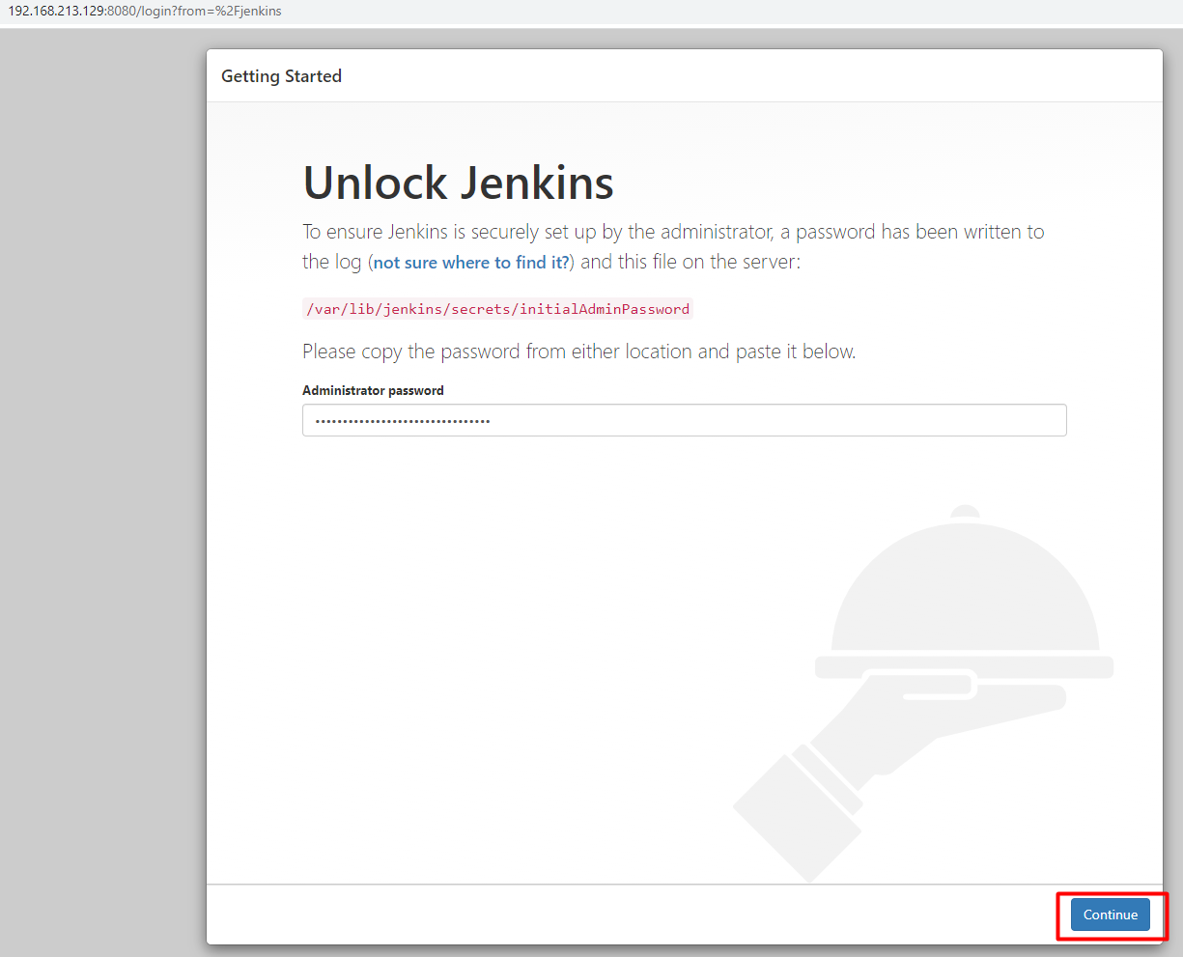

Use the following command to print the password on your terminal:

**# sudo cat /var/lib/jenkins/secrets/initialAdminPassword**

You should see a 32-character long alphanumeric password as shown below:



Copy the password from your terminal, paste it into the Administrator password field and click Continue.